**Experiment 31**

**Lab Book:**



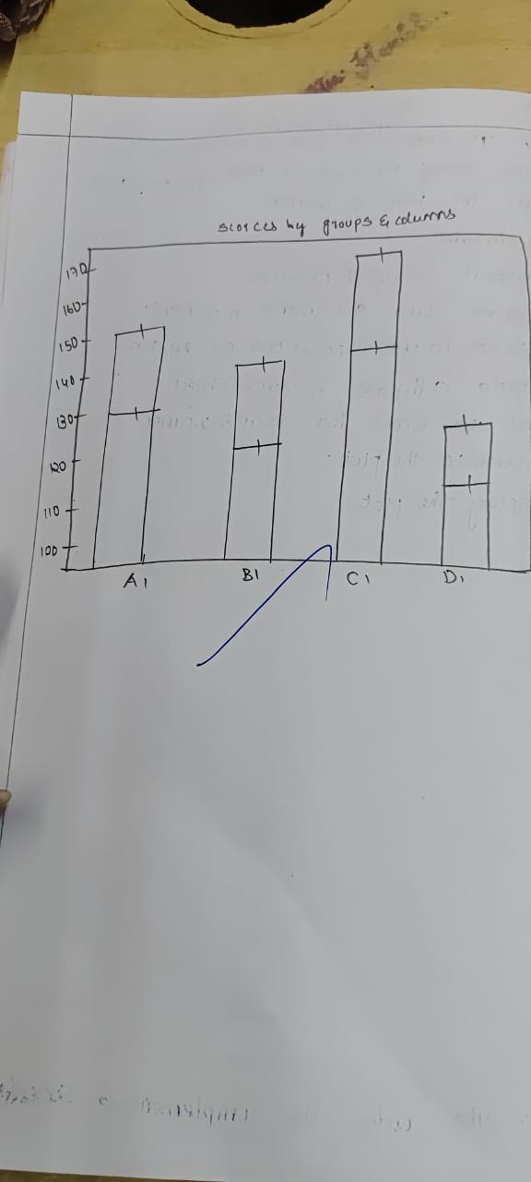

**Code**

import matplotlib.pyplot as plt

import numpy as np

x = np.arange(5)

men_means = [22, 30, 35, 35, 26]

women_means = [25, 32, 30, 35, 29]

men_std = [4, 3, 4, 1, 5]

women_std = [3, 5, 2, 3, 3]

plt.bar(x, men_means, yerr=men_std, label='Men')

plt.bar(x, women_means, yerr=women_std, bottom=men_means, label='Women')

plt.legend()

plt.show()

**Sample Output**

